David Rosenblatt, Psy.D.
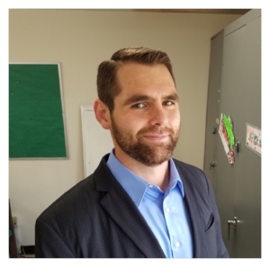
License number: PSY 28428
Phone number: 805-457-5792
Address: P.O. Box 3173
Atascadero, CA 93423
E-mail: David@DoctorDavidR.com
Website: DoctorDavidR.com
_______________________________________________
University/School Attended: Loma Linda University
Year Graduated: 2015
Insurance Accepted: CenCal through Holman Group
Treatment Modalities: Individual therapy; couples therapy; family therapy; and psychological testing.
Problems Treated: Psychological trauma, PTSD, anxiety, depression, obsessive thoughts, phase of life, adjustment, communication, tobacco cessation, and sleep. Any other questions, just ask.
Primary Theoretical Orientation: Gestalt Therapy - a here and now approach. The focus is the client's experience during the conversation. Healing is natural, but life can be tough so sometimes a person learns unhealthy ways that block the body from healing. When one experiences a block with fuller awareness, the body can heal. We are both experts in life and my goal is to create a safe space in which you to embrace your power and agency to learn how to heal again. I received extensive training from Gestalt Associates Training Los Angeles (GATLA).
Specialty Areas: Trauma/PTSD
For further information, please call the telephone number, send an email to, or visit the website listed above.
Thank you!

